Project Design Phase-II
Data Flow Diagram & User Stories

Date | 30 September 2026
Team ID | MKU201Team56ab4dc836f290be8a6b49be8
Project Name | Import Data Using Transform Maps (ServiceNow Micro Project)
Maximum Marks | 4 Marks

Data Flow Diagrams:
A Data Flow Diagram (DFD) is a traditional visual representation of the information flows within a system. A neat and clear DFD can depict the right amount of the system requirement graphically. It shows how data enters and leaves the system, what changes the information, and where data is stored.
DFD Level 0 – Import & Report Employee Data
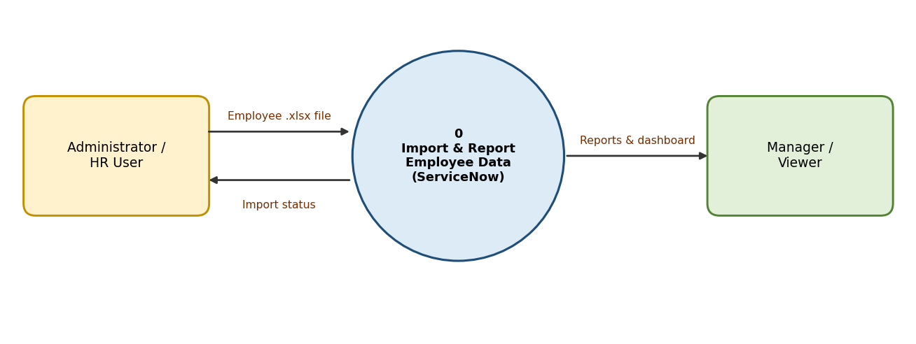
DFD Level 1 – Detailed process flow
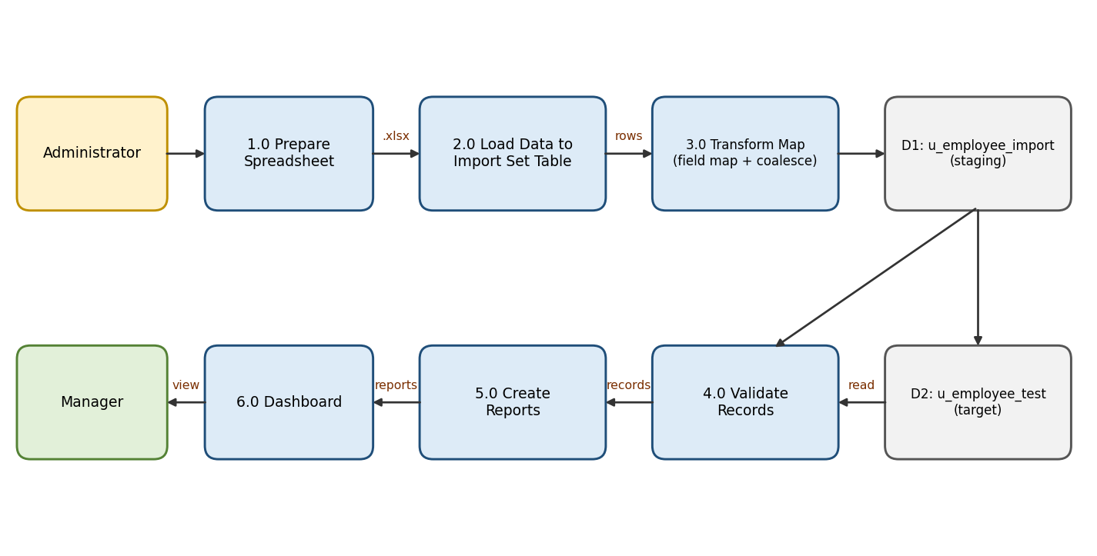

User Stories
Use the below template to list all the user stories for the product.
User Type | Functional Requirement (Epic) | User Story Number | User Story / Task | Acceptance criteria | Priority | Release
HR / ServiceNow Admin | Data Preparation | USN-1 | As an admin, I can prepare an employee spreadsheet with a header row (Employee ID, Employee Name, Email, Department, Location) and save it as .xlsx | File is saved as .xlsx with all five columns and sample data | High | Sprint-1
 | Table Creation | USN-2 | As an admin, I can create a custom table 'Employee Test' (u_employee_test) | Table appears under System Definition → Tables | High | Sprint-1
 |  | USN-3 | As an admin, I can add the five String fields to the Employee Test form | All five fields visible on the form layout | High | Sprint-1
 | Import Set | USN-4 | As an admin, I can create the import set table 'Employee Import' using Load Data | u_employee_import is created and spreadsheet rows are staged | High | Sprint-1
 | Transform Map | USN-5 | As an admin, I can create the Transform Map 'Sample Spreadsheet Import' from Employee Import to Employee Test | Source and target tables are set correctly | High | Sprint-2
 |  | USN-6 | As an admin, I can map the five source columns to the five target fields | All five field maps are present after saving | High | Sprint-2
 |  | USN-7 | As an admin, I can run the transform and validate imported records against the spreadsheet | Employee Test rows and values match the source data | High | Sprint-2
 | Duplicate Handling | USN-8 | As an admin, I can set Coalesce = true on Employee ID so existing records are updated | Re-import updates existing IDs and inserts only new IDs; no duplicates | High | Sprint-2
 | Re-import | USN-9 | As an admin, I can upload an updated spreadsheet and re-run the transform | 2 existing IDs updated, 2 new IDs inserted; unchanged re-import causes no new changes | Medium | Sprint-3
Manager / Viewer | Reports | USN-10 | As a manager, I can view Employees by Department (pie), Employees by Location (bar) and an Employee List report | Three reports run and are saved | Medium | Sprint-3
 | Dashboard | USN-11 | As a manager, I can open one dashboard containing all three reports | Employee Analytics Dashboards shows three widgets | Medium | Sprint-3
System Administrator (ACL) | Access Control | USN-12 | As a system administrator, I can adjust ACL / access for the dashboard table if creation is blocked | Authorized admin can create the dashboard; others cannot change ACLs | Low | Sprint-3

